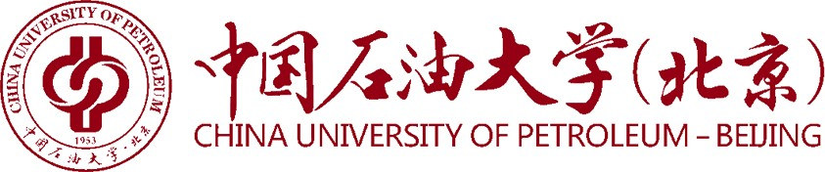

CERTIFICATE OF REGISTRATION

November 13, 2023
To whom it may concern:

This is to certify that Mr. ZhangSan, born on October 1, 2001, national ID No.55500500000000, is registered as a full-time student on the bachelor degree programme in Data Science and Big Data Technology in the Faculty of Petroleum, China University of Petroleum–Beijing at Karamay, since September, 2020. The normal duration of programme is 4 years.Now he is in his Fourth year of study. He has completed three years of study.

Department of Teaching Affairs
China University of Petroleum-Beijing at Karamay

